**URL:** <https://leetcode.com/problems/second-highest-salary/description/>

**DDL:**

Create table If Not Exists Employee (id int, salary int)

Truncate table Employee

insert into Employee (id, salary) values ('1', '100')

insert into Employee (id, salary) values ('2', '200')

insert into Employee (id, salary) values ('3', '300')

Create table Employee1 (id int, salary int);

Truncate table Employee1;

insert into Employee (id, salary) values ('1', '100')

Problem Statement:

Table: Employee

+-------------+------+

| Column Name | Type |

+-------------+------+

| id | int |

| salary | int |

+-------------+------+

id is the primary key (column with unique values) for this table.

Each row of this table contains information about the salary of an employee.

Write a solution to find the second highest salary from the Employee table. If there is no second highest salary, return null (return None in Pandas).

The result format is in the following example.

**Example 1:**

**Input:**

Employee table:

+----+--------+

| id | salary |

+----+--------+

| 1 | 100 |

| 2 | 200 |

| 3 | 300 |

+----+--------+

**Output:**

+---------------------+

| SecondHighestSalary |

+---------------------+

| 200 |

+---------------------+

**Example 2:**

**Input:**

Employee table:

+----+--------+

| id | salary |

+----+--------+

| 1 | 100 |

+----+--------+

**Output:**

+---------------------+

| SecondHighestSalary |

+---------------------+

| null |

+---------------------+

**Query:**

select max(salary) as SecondHighestSalary

from Employee where salary not in (select max(salary) from Employee)

**Test case Result 1:**

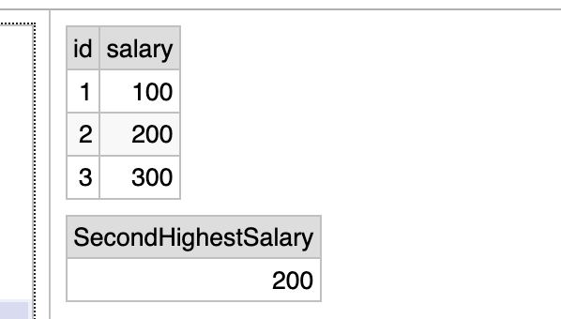

**Query:**

select max(salary) as SecondHighestSalary

from Employee1 where salary not in (select max(salary) from Employee1);

**Test case Result 2:**

